Analysis & Design of Algorithms
LAB Assignment – 2
Name – Jyoti Suryavanshi
Roll No. - 2401010291
Course – B.Tech CSE Core
Section – C
Github-https://github.com/suryavanshijyoti360-blip

Task 1: Divide and Conquer (Merge Sort):
Aim:
To implement Merge Sort using Divide and Conquer and analyze its performance.
Input:
Random array of integers of different sizes.

Solution :-

import time
import random
import matplotlib.pyplot as plt

def merge_sort(arr):
if len(arr) <= 1:
return arr

mid = len(arr) // 2
left = merge_sort(arr[:mid])
right = merge_sort(arr[mid:])

return merge(left, right)

def merge(left, right):
result = []
i = j = 0

while i < len(left) and j < len(right):
if left[i] < right[j]:
result.append(left[i])
i += 1
else:
result.append(right[j])
j += 1

result.extend(left[i:])
result.extend(right[j:])
return result

sizes = [100, 200, 300, 400, 500, 600, 700]
times = []

for size in sizes:
arr = [random.randint(1, 1000) for _ in range(size)]

start = time.time()
merge_sort(arr)
end = time.time()

times.append(end - start)

plt.figure()
plt.plot(sizes, times, marker='o')

plt.xlabel("Input Size")
plt.ylabel("Time (seconds)")
plt.title("Merge Sort Performance (Divide & Conquer)")
plt.grid()

plt.show()
Graph:
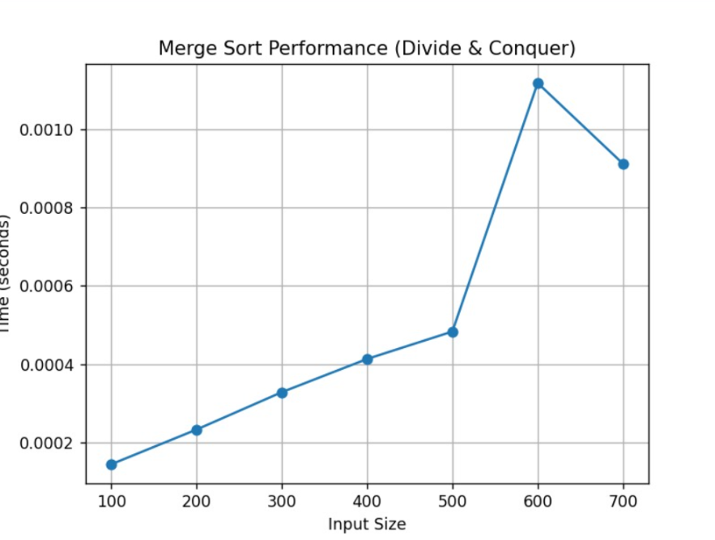

Task 2: Sorting Comparison:
Aim:
To compare Bubble Sort, Merge Sort, and Quick Sort.
Input:
Random arrays of different sizes.

Solution :-
import time
import random
import matplotlib.pyplot as plt

def bubble_sort(arr):
arr = arr.copy()
n = len(arr)
for i in range(n):
for j in rane(0, n-i-1):
if arr[j] > arr[j+1]:
arr[j], arr[j+1] = arr[j+1], arr[j]
return arr

def merge_sort(arr):
if len(arr) <= 1:
return arr
mid = len(arr)//2
left = merge_sort(arr[:mid])
right = merge_sort(arr[mid:])
return merge(left, right)

def merge(left, right):
result = []
i = j = 0
while i < len(left) and j < len(right):
if left[i] < right[j]:
result.append(left[i])
i += 1
else:
result.append(right[j])
j += 1
result.extend(left[i:])
result.extend(right[j:])
return result

def quick_sort(arr):
if len(arr) <= 1:
return arr
pivot = arr[len(arr)//2]
left = [x for x in arr if x < pivot]
middle = [x for x in arr if x == pivot]
right = [x for x in arr if x > pivot]
return quick_sort(left) + middle + quick_sort(right)

sizes = [200, 400, 600, 800, 1000]

bubble_times = []
merge_times = []
quick_times = []

for size in sizes:
arr = [random.randint(1, 10000) for _ in range(size)]

start = time.perf_counter()
bubble_sort(arr)
bubble_times.append(time.perf_counter() - start)

start = time.perf_counter()
merge_sort(arr)
merge_times.append(time.perf_counter() - start)

start = time.perf_counter()
quick_sort(arr)
quick_times.append(time.perf_counter() - start)

plt.figure(figsize=(8,5))

plt.plot(sizes, bubble_times, marker='o', label="Bubble Sort")
plt.plot(sizes, merge_times, marker='o', label="Merge Sort")
plt.plot(sizes, quick_times, marker='o', label="Quick Sort")

plt.xlabel("Input Size")
plt.ylabel("Time (seconds)")
plt.title("Sorting Algorithm Comparison")
plt.legend()
plt.grid()

plt.show()
print("Graph saved as sorting_comparison.png")
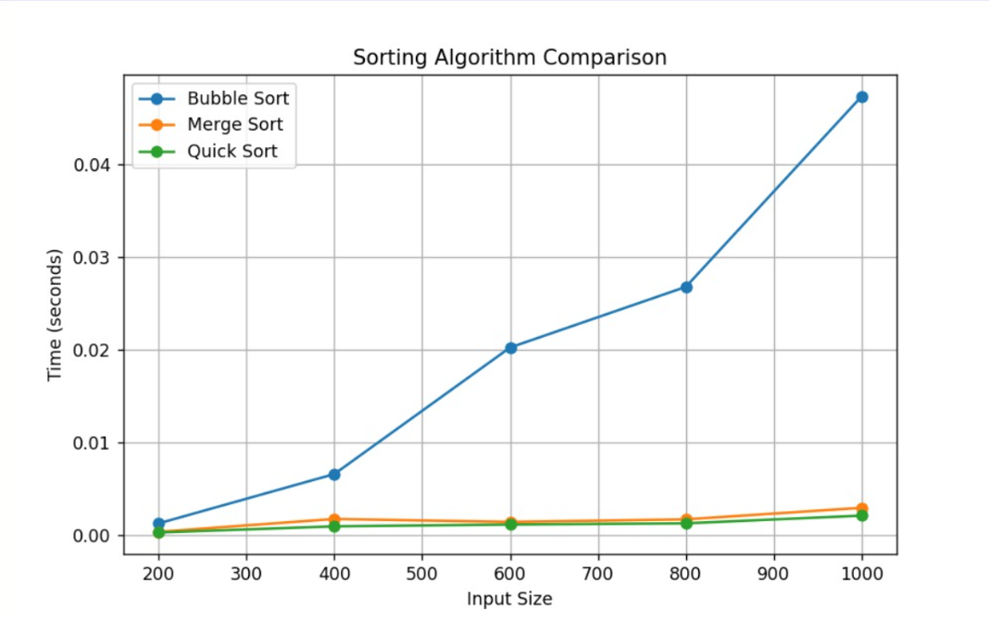

Task 3: Greedy Algorithm (Fractional Knapsack):
Aim:
To solve knapsack problem using greedy approach.
Input:
Weights, values, and capacity.

Solution :-
import time
import random
import matplotlib.pyplot as plt

def fractional_knapsack(weights, values, capacity):
items = []

for i in range(len(weights)):
ratio = values[i] / weights[i]
items.append((ratio, weights[i], values[i]))
items.sort(reverse=True)

total_value = 0

for ratio, weight, value in items:
if capacity >= weight:
capacity -= weight
total_value += value
else:
total_value += ratio * capacity
break

return total_value

weights = [10, 20, 30]
values = [60, 100, 120]
capacity = 50

print("Maximum Value:", fractional_knapsack(weights, values, capacity))

sizes = [10, 20, 30, 40, 50, 60, 70]
times = []

for size in sizes:
weights = [random.randint(1, 50) for _ in range(size)]
values = [random.randint(10, 200) for _ in range(size)]
capacity = 100

start = time.perf_counter()
fractional_knapsack(weights, values, capacity)
times.append(time.perf_counter() - start)

plt.figure(figsize=(8,5))
plt.plot(sizes, times, marker='o')

plt.xlabel("Number of Items")
plt.ylabel("Time (seconds)")
plt.title("Fractional Knapsack (Greedy) Performance")
plt.grid()

plt.show()
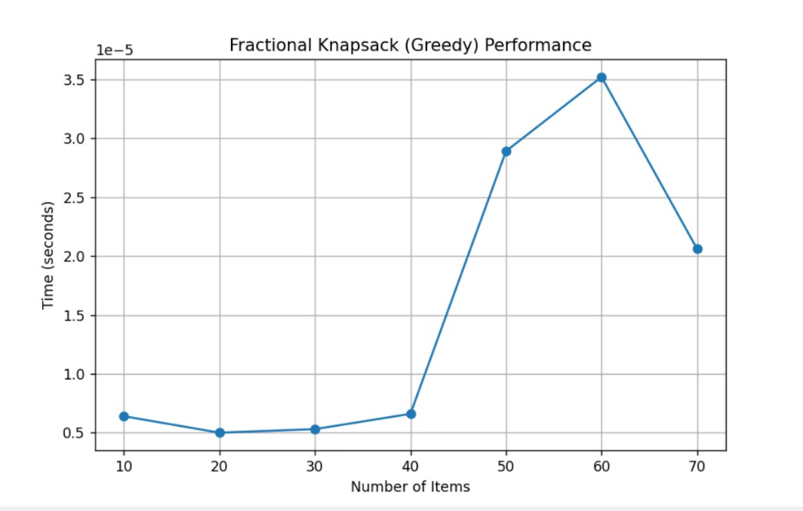
Task 4: Dynamic Programming (0/1 Knapsack)
Aim:
To solve knapsack using dynamic programming.
Input:
Weights, values, capacity
Solution :-
import time
import random
import matplotlib.pyplot as plt

def knapsack(W, wt, val):
n = len(wt)

dp = [[0 for _ in range(W+1)] for _ in range(n+1)]

for i in range(1, n+1):
for w in range(W+1):
if wt[i-1] <= w:
dp[i][w] = max(val[i-1] + dp[i-1][w-wt[i-1]], dp[i-1][w])
else:
dp[i][w] = dp[i-1][w]

return dp[n][W]

wt = [10, 20, 30]
val = [60, 100, 120]
W = 50

print("Maximum Profit:", knapsack(W, wt, val))

sizes = [5, 10, 15, 20, 25]
times = []

for size in sizes:
wt = [random.randint(1, 30) for _ in range(size)]
val = [random.randint(10, 200) for _ in range(size)]
W = 50

start = time.perf_counter()
knapsack(W, wt, val)
times.append(time.perf_counter() - start)

plt.figure(figsize=(8,5))
plt.plot(sizes, times, marker='o')

plt.xlabel("Number of Items")
plt.ylabel("Time (seconds)")
plt.title("0/1 Knapsack (Dynamic Programming) Performance")
plt.grid()
plt.show()
Graph:
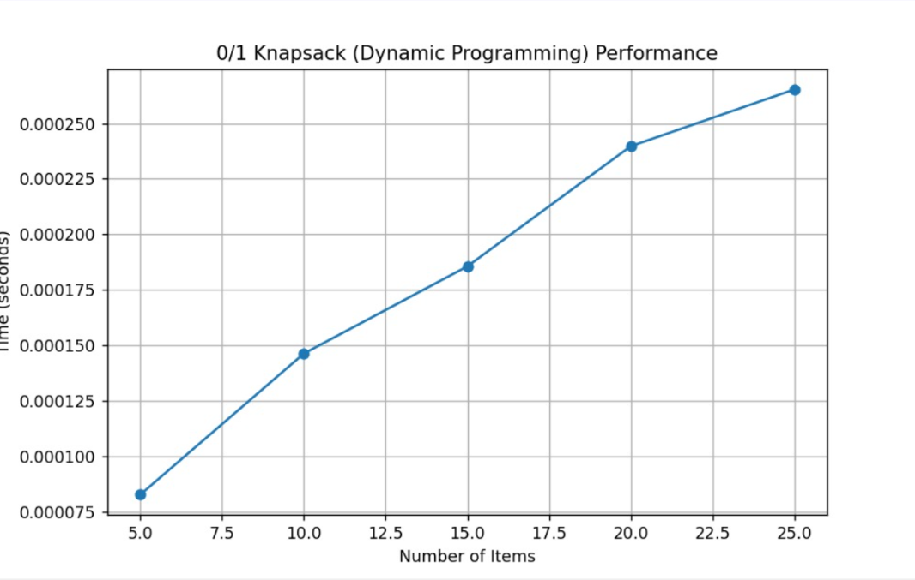
Task 5: Travelling Salesman Problem (TSP)
Aim:
To solve TSP and observe exponential growth.
Input:
Distance matrix of cities.
import time
import random
import matplotlib.pyplot as plt
from itertools import permutations

def tsp(graph):
n = len(graph)
cities = list(range(n))
min_cost = float('inf')

for perm in permutations(cities[1:]):
path = [0] + list(perm) + [0]
cost = 0

for i in range(len(path) - 1):
cost += graph[path[i]][path[i+1]]

if cost < min_cost:
min_cost = cost

return min_cost

graph = [
[0, 10, 15, 20],
[10, 0, 35, 25],
[15, 35, 0, 30],
[20, 25, 30, 0]
]

print("Minimum Cost:", tsp(graph))

sizes = [3, 4, 5, 6]
times = []

for n in sizes:

graph = [[0 if i == j else random.randint(10, 50) for j in range(n)] for i in range(n)]

start = time.perf_counter()
tsp(graph)
times.append(time.perf_counter() - start)

plt.figure(figsize=(8,5))
plt.plot(sizes, times, marker='o')

plt.xlabel("Number of Cities")
plt.ylabel("Time (seconds)")
plt.title("TSP Exponential Growth")
plt.grid()
plt.show()
Graph:
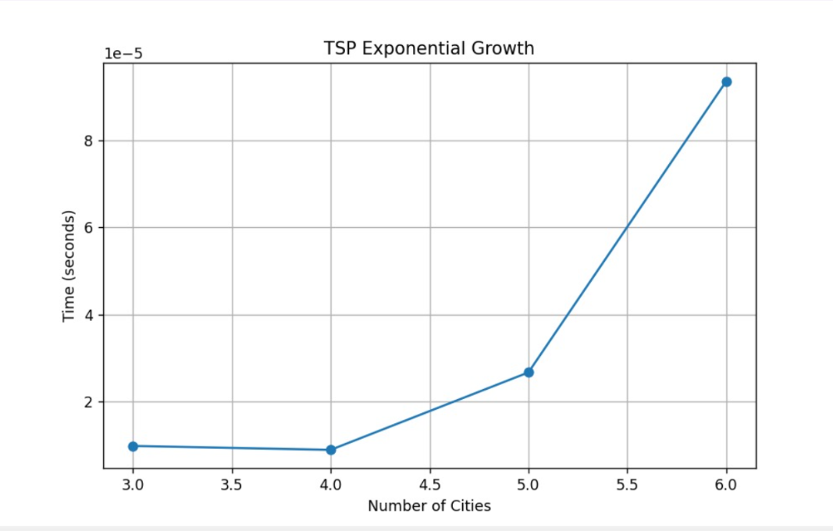
Github link:
https://github.com/Poojahr16/https-github.com-yourname-algo-strategies-mini-project-Pooja/releases/tag/v1.0-submission

